**ANJIES ARCADE Final Year Project Report**

**P2656422 Anjuma Rouf**

**CONTENTS**

**Introduction______________________________________________________________3**

**Project Management_____________________________________________________4**

**Project Plan and Ideas____________________________________________________5**

**Development____________________________________________________________6**

**Arcade Room**

**Menu**

**Runner**

**Cat Escape**

**Maze**

**UI**

**What is UI**

**Principals**

**Process**

**Lighting**

**Further Research**

**Further Development**

**Hurdles**

**Time Constraints**

**Conclusion**

**References**

**INTRODUCTION:**

**What the project is:**

This project is a game development project where the Player can play various minigames in a setting and explore a very bright and colourful world. The player can access a lobby in which they can interact with various objects and minigames. There are 3 different games the player has access to they can play these games over and over again. Each minigame has a different style of gameplay with different themes to keep the experience fresh.

**Intended outcome:**

The main goal for the project is to have a playable character for each of the game scenes that can be controlled. The main player lobby, the character should be able to walk around the area and be able to access the different minigames at each of their stations. This also includes being able to interact with different objects around the room such as posters and plants.

For the minigames, each game should be fully playable with individual scoring system. Each game will have its own objectives such as for the Maze game; it will be that the player has to make their way through the maze and collect coins throughout then find the exit. For the endless runner game, the player must dodge obstacles and collect coins once again, as the game goes on the player will get faster until the player crashes into an object where the score will be displayed to them. For the final game it’s a 2D arcade game where the player (who is a cat) must escape a dog that’s chasing them while collecting health pickups displayed as fish. They must also collect coins around the map, each time they get a certain interval of coins another dog will show up to make the game harder.

**PROJECT MANAGEMENT**

**Agile:**

For this project the Agile methodology was used as it was the best style for this project, this is due to the nature of the project as it is a very back and forth process where many different changes occur. Multiple occasions during the project the original project plan was revisited to adjust for changes and delays in development, this was mainly due to personal circumstances such as sickness or other module deadlines.

**Trello:**

For this project I have used Trello to organise all my tasks and general project management.

This is my Trello board for this project around halfway through development. 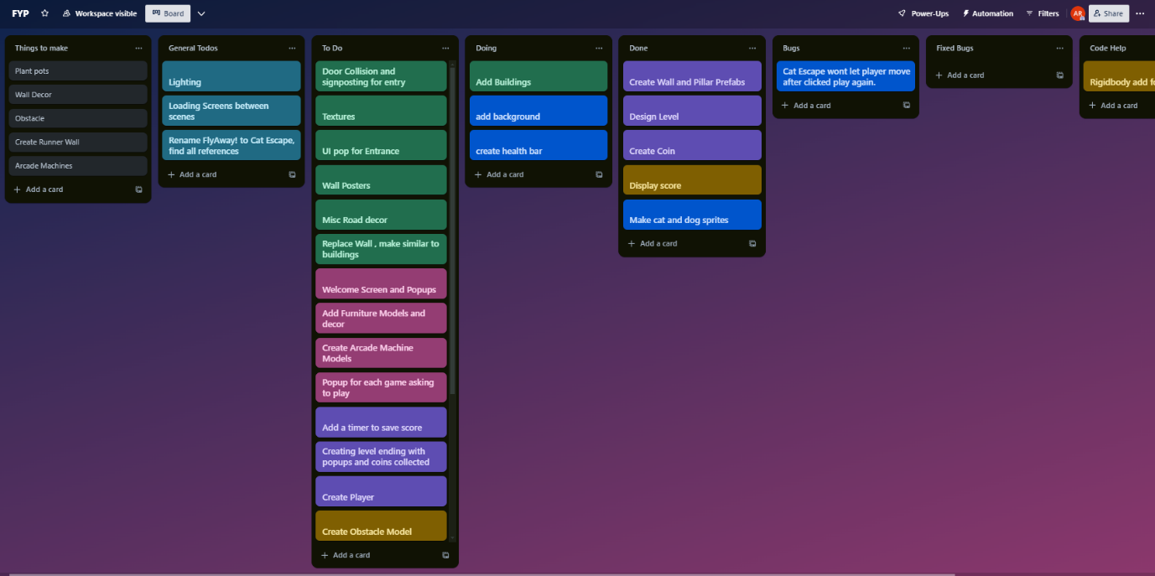

As the project is worked on the Trello is constantly updated with new tasks and adjusting any existing tasks. It also allows me to see which tasks I have already completed without having to re check the whole project to find what I have already completed.

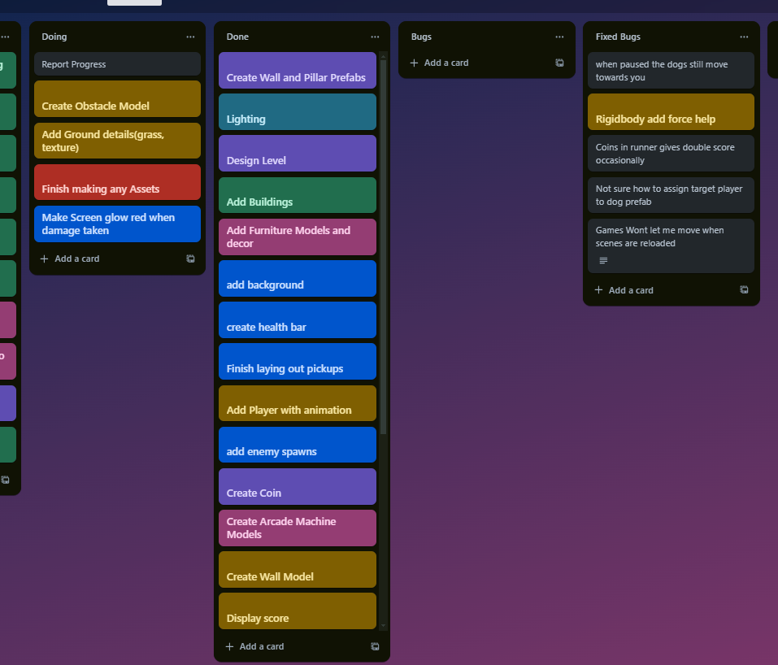

This is towards the end of the project where a lot of features and elements have been completed and put inside the Done tab. Many of the code and feature bugs were documented and fixed later on that will be talked about.

To make things easier, I colour coded each square to relate to a particular aspect of the game:

Blue: General Project tasks

Green: Menu Scene Tasks

Pink: Arcade Room Tasks

Purple: Maze game Tasks

Yellow: Endless Runner game Tasks

Blue: Cat Escape Tasks

Having the colours this way makes it easier to see what aspects need more work to be done on them to allow a more consistent time scale on the progress so certain parts of the game are not massively behind others.

The Trello is also being used to track different bugs within the game that can later be discussed in this report, this has been done instead of simply fixing the bugs and removing it off the board.

**Gantt Chart**

The Gantt Chart for this project was primarily used for managing time on the project in comparison to the Trello which was used for the development portion of the Timeline itself. It allowed the project to be separated into different chunks to allow for time in each so that tasks didn’t overlap where it wasn’t necessary. It also allowed for good time management at the start of the project where a large portion of it was documentation and planning.

**PROJECT PLAN AND IDEAS:**

**Level Design**

The plan for the level design is aimed to be aminimalistic but simple layout and design with bright colours to bring more life to the game and make it more engaging. Each scene in the project will have a similar style with bold colours that will offset each other to allow important objects to be seen more clearly for example, in a minigame with obstacles they will be a relevant colour to showcase this. **Player Designs**

Each player for the scenes within the game are purely for being able to interact with the rest of the game, as of this moment they are not relevant to the story of the game or its world. The player in the minigames have an aim and that is complete or gain as many coins as possible. The player will have its own camera setting to be able to move around freely in the scenes. Some of the minigames have limited movement such as the endless runner the player only has control over left and right movement while the player slowly accelerates forward. **Gameplay Ideas**

The gameplay will vary between scenes such as the main lobby the player can go around the room and interact with different objects.

The Minigames have different main gameplay aspects but also have very similar aspects such as coin collection will be the same throughout. Each minigame will have its own mechanic that is the focus of that game

**DEVELOPMENT**

**Arcade Room:**

The development for the arcade room began with blocking out the layout of the scene, this included the Main Bar area, the games area and the cosy area. By using the basic Unity 3d objects the layout of the lobby was mainly done which I could then plan the 3D models that would be used in the scene.

Character:

The character player for this game was mainly decided as it was a simple design that the player could use as a means to access the different minigames for the project. It is a simple animated character that brings more interest to the main lobby area.

Design:

The initial plan for the design portion of the lobby was to have separate rooms that the player can explore, however this was changed to make the rooms fuller by making it one larger room and putting all the room decorations and furniture in one space instead of 3. This also allowed a much faster turnaround to get the rooms looking much more lively with the lighting and furniture in place.

Models:

The models for this project have been chosen to fit the low poly style of the game, The furniture pack that was used for the lobby area, certain objects were picked to be used in the scene such as the cabinets and sofas.

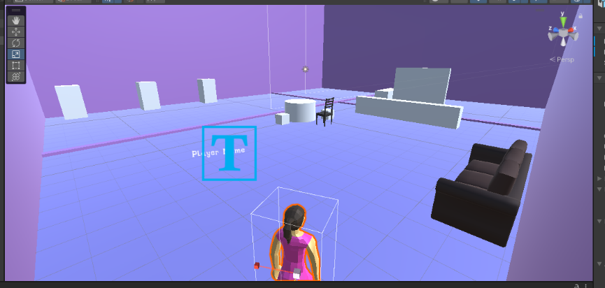

This is the early stage of development where it was mainly blocking out the level design and making sure the player character controller was working properly. It was also the initial stage of testing the UI to give it a better HUD look however later on this was changed to be purely on the canvas as doing it this way made it harder to manage with the HUD elements being in world space.

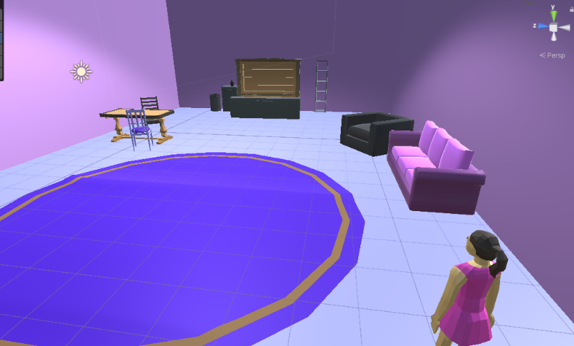

At this stage of development more work was done on the minigames so the lobby area was less developed at this stage. Some experimentation was done with the chosen models to see how they fit within the scene as well as changing around textures and colours to fit the scene more. Some experimentation was also done on the textures of the model to have some more variety and increase the brightness of some of the colours.

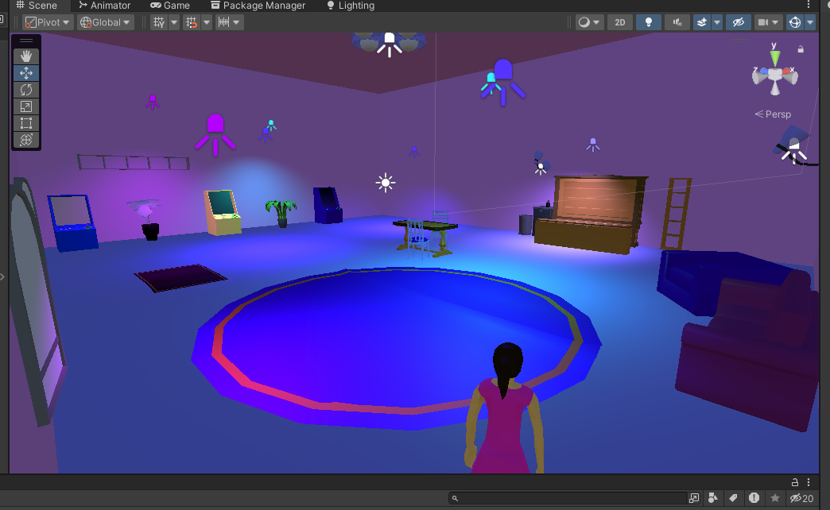

At this more developed stage a lot of the implementation was done to ensure all the scene changes were working correctly. To start with, the Interact feature was added to the Arcade machine models where a popup would appear next to the game and allow the player to play the minigame they wished. After this was polished further work went into the room design and this is when the layout plan had changed into one large room instead of separate rooms. More models were then added into the scene and some initial work began on the lighting in the room with various coloured spotlights and point lights on the walls.

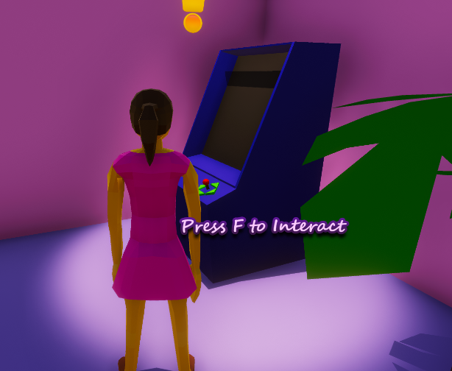

Once the main minigame functions were majorly completed I added some world space UI to the scene in the form of indicators above the arcade machines.

**Menu:**

Plan and Design:

The idea for the Menu area was to have a first-person player that can roam around this small street that leads into the Arcade entrance. As soon as the player enters the game there will be ambient street noises and a main road the player looks into but not go onto. The plan was to have different signage posters along the walls to direct the player towards the Main entrance where some UI animations would be used to showcase the Main Menu. It will contain the base controls for the lobby and allow the player to enter the Lobby area.

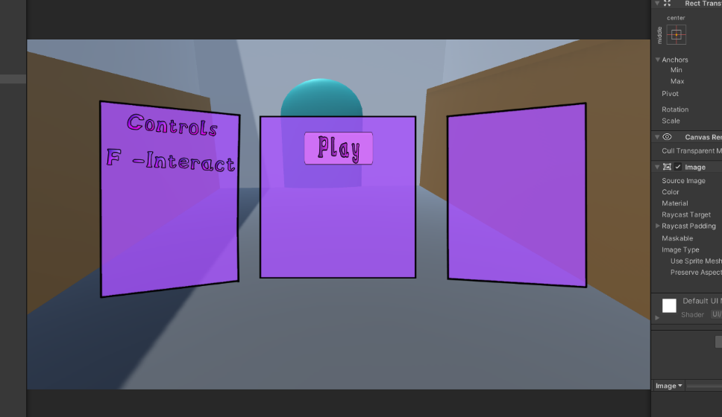

This is the early stage of the Main Menu development, it was primarily experimenting with the Unity Canvas and playing around with depth to make it appear as though the Menu is floating in the world rather than flat and static on the screen. After playing around with the Menu, blocking out the scene was next. Using various Unity shapes to block out where different buildings were going to and then using some basic materials gave a good base to work with when importing models.

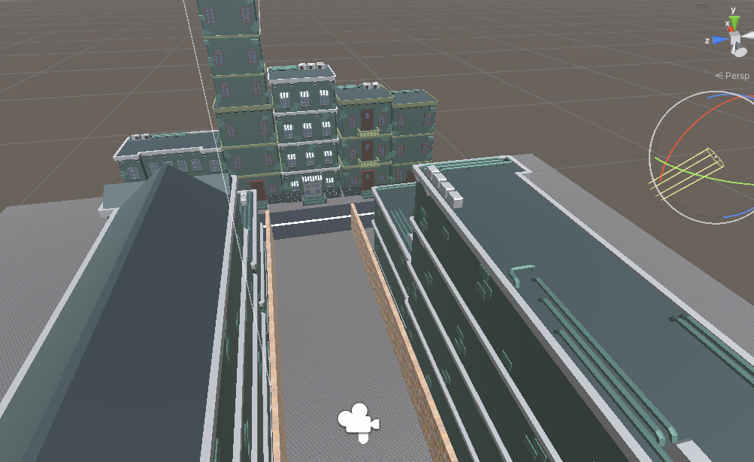

After the Basic Menu was implemented, next began the actual scene development. This started off by importing some building models into the scene, the idea was to have buildings surrounding the starting area for the player, so it appears more lively. The Layout for the scene was made so that only one street is seen by the player and is filled with background noise and ambience.

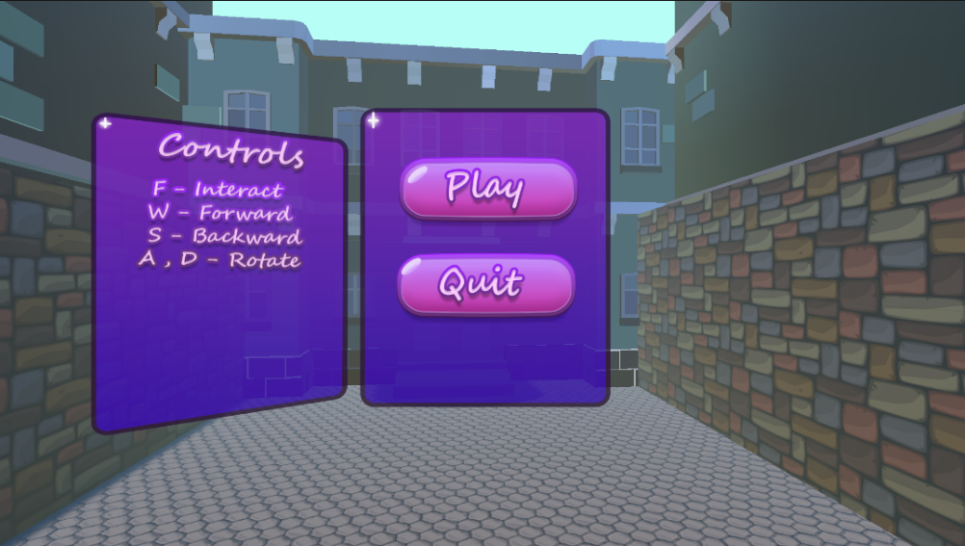

This stage of development was working on the UI design of the game, I had chosen to do a bubbly themed UI to make everything stand out to the player more. Once I had created the assets I replaced the initial placeholders with them instead. Many of the UI assets used throughout the game use the same style and have simple off screen and on-screen animations.

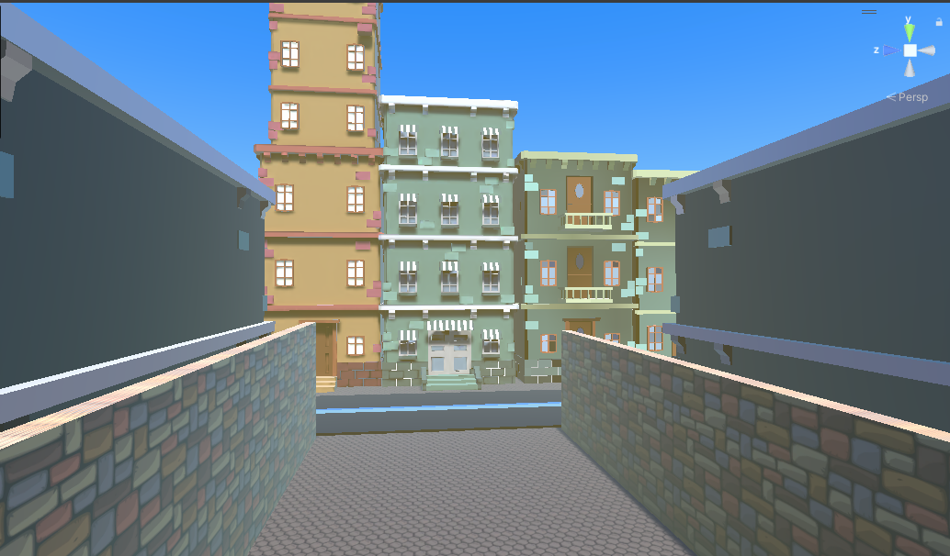

This part of the Menu scene development was looking into some atmospheric lighting and fog settings, I experimented with URP settings to change up the lighting but this was later changed as it didn’t work as intended. I changed up the colours on some of the buildings to give them some variety and make the street appear more interesting instead of just the same buildings repeated over and over again. The fog settings were then looked at to give some distance perception to the player, after playing around with some of the colours giving the fog a yellow tint worked better than some of the other colours.

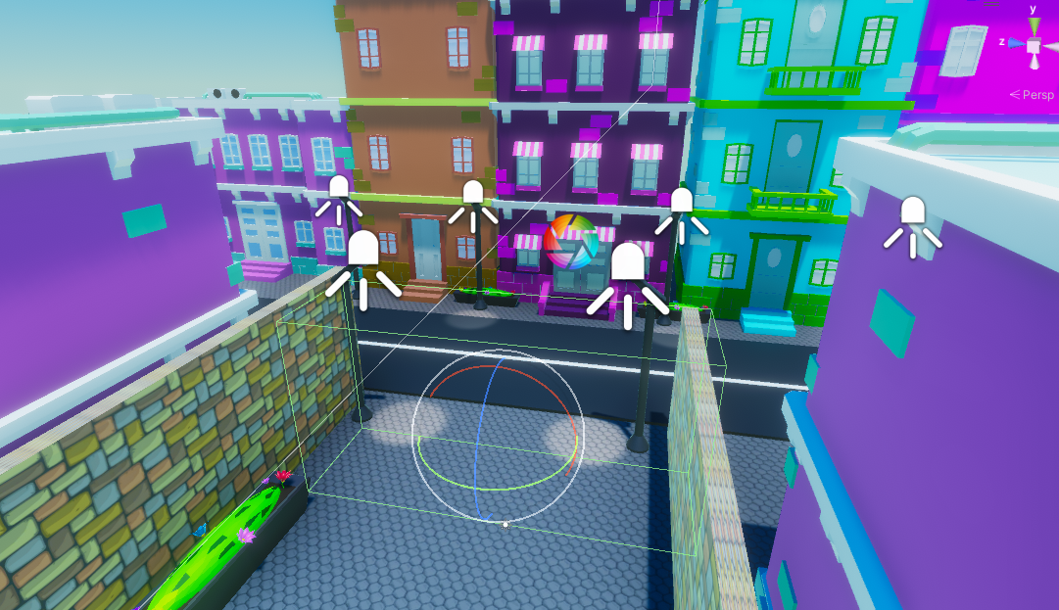

At this stage, much more work was done to the Menu environment as a whole, this included the later mentioned Post Processing feature that made the scene lighting much more atmospheric. The buildings were given a variety of colours and adjusted brightness, so they didn’t seem dull and some more models were added to the scene including some spotlights and flower beds.

The street was given an invisible wall so the player cannot explore the main street, this is due to ensuring the player goes towards the main entrance of the Arcade Lobby where majority of the game is focussed.

**Cat Escape**

Plan and Design:

For this minigame the idea was for it to be a simple but enjoyable game where the plays has a map they can travel around, I chose to make this a 2d game so the 3 initial minigames have different styles and gameplay. At first, I did not have a set theme for the game so just used placeholder characters in order to get the mechanics working, later on it was decided to make it cat and dog where the player is the cat, and the enemy is the dog that chases the player around.

The Map itself is a simple park/garden that has trees and collectibles laying around, such as coins and health pickups as the player loses lives when they come into contact with the enemy. The player has 3 lives which is displayed to them in the corner of their screen, each time they collide with the enemy the number will go down. Each time the player collects a coin they gain a score which is then saved and used later in the Arcade Room, when the coin is collected its then spawned again randomly throughout the map that the player has to then go find while avoiding the enemy.

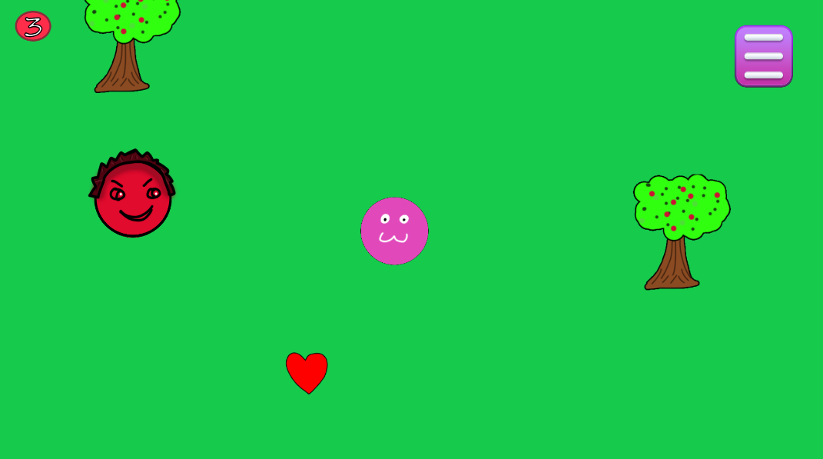Every 5 coins collected the game will spawn another dog to make the game harder for the player as at the start it is quite easy to play. This can then go on until the player uses up all their lives as there is limited health pickups around the map so eventually, they will run out.

After the planning this is the first initial stage of the game where it was mainly just getting the mechanics of the game functioning such as the player movement and enemy movement. I also drew up some initial sprites to see how the layout of the map would look. I also made sure to check the Menus were functioning correctly and link all the buttons to scene changes such as the quit button taking the player back to the lobby or the Menu scene.

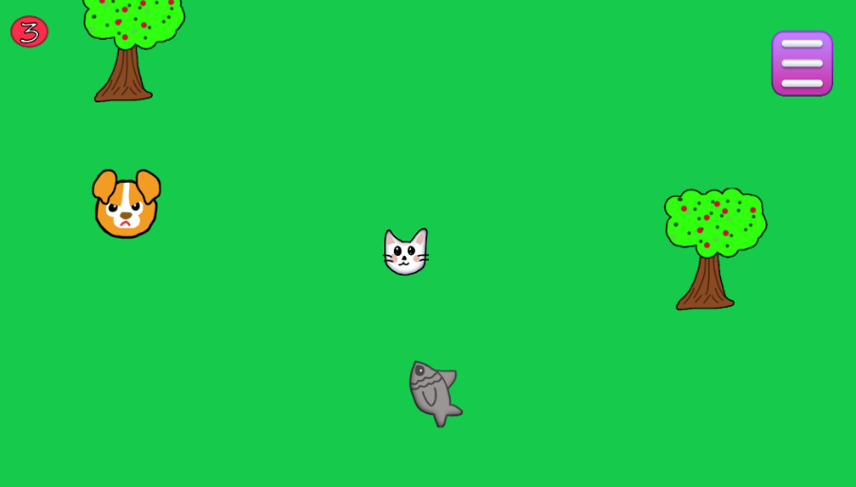

At this point of the development I had finished up the basic mechanics of the game and decided to go back into photoshop and draw some character sprites for the game as I had chosen the theme which was cat and dog chase, this was also the stage where I chose a name of the game as initially it was called Fly Away! I then played around with the 2D layers in the game and experimented with the trees having colliders, this was later changed as the coins would often spawn behind a tree and the player was not able to collect them. Ensuring the fish were working correctly was also done at this stage, a feature was added where the player can’t physically collect them if the player had full health so the fish would remain where they are.

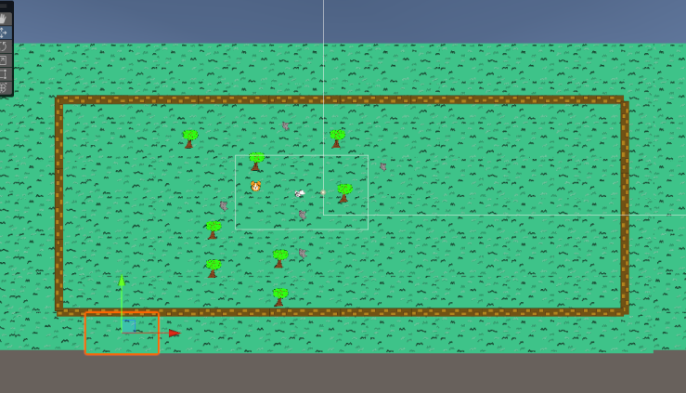

This image is just a more general progress of what the map is looking like, the fish have since been added throughout the map for the player to collect. And ensuring the random number values are correct for the coin generation. A score UI was also added at this stage for the player to view how much they have collected.

**Runner**

Plan and Design:

For this minigame the idea was a very simple Endless Runner where the player speeds up over time and has to dodge obstacles in front of them as well as collect coins as they go. The player only has one life so if they hit an obstacle the game is over for them and they have to restart. The theme of the game is very basic and doesn’t have a set theme except from the grass ground and walls along the sides. The obstacles are bright to show the player that they shouldn’t run into them, or they will lose.

The player will gain score from collecting coins throughout the run however won’t be penalised for missing any coins as the main point is that they collect them to gain a score. This score will be saved similar to the 2D minigame and can be used later in the Arcade Room.

The Menu system for the minigame will be the same as all the others where a popup will appear at the start of the game to explain how to play it and the player can then press a button to begin the game.

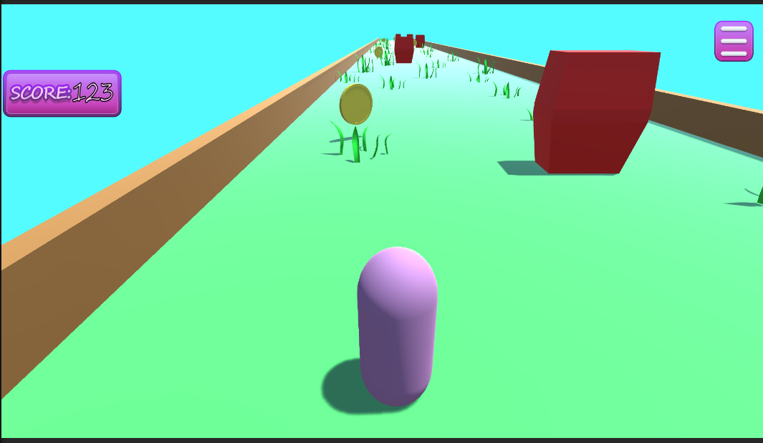

At this stage of development, it was primarily ensuring all the mechanics worked within the game, this included making the platforms spawn correctly and endlessly without error and ensuring all the collectibles and obstacles spawned accordingly and randomly on the platforms. The platforms are generated on play instead of preset in the game, 5 initial platforms are spawned at the start and every time the player hits the trigger on the end of the first platform another is spawned onto the end and the platform behind the player is deleted. The platforms are stored in a list so there is only a set number of platforms in the game at each time to prevent lagging. Each instance a platform is generated 3 obstacles, and 3 coins also spawn on the platform in random set locations along the track for the player to collect. The platform on the back of the list is then moved to the front using the GroundMove() function.

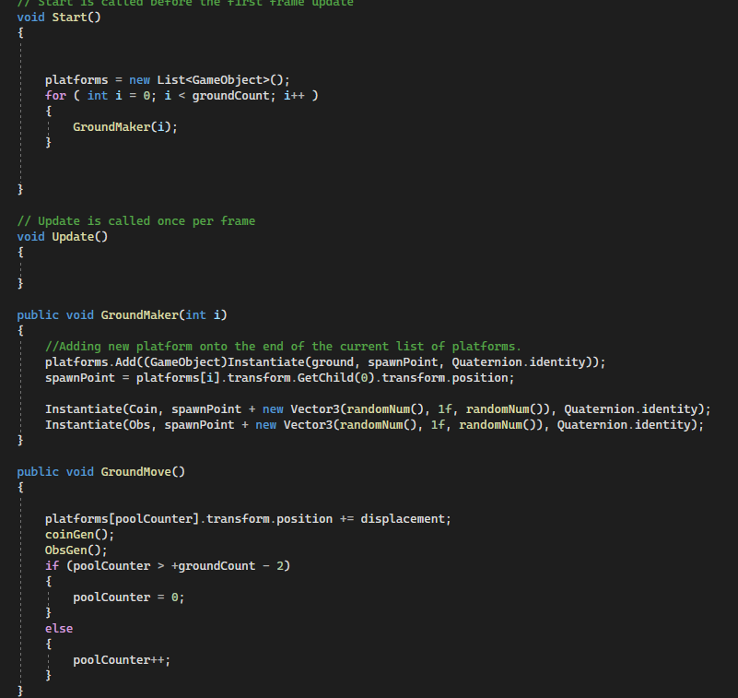

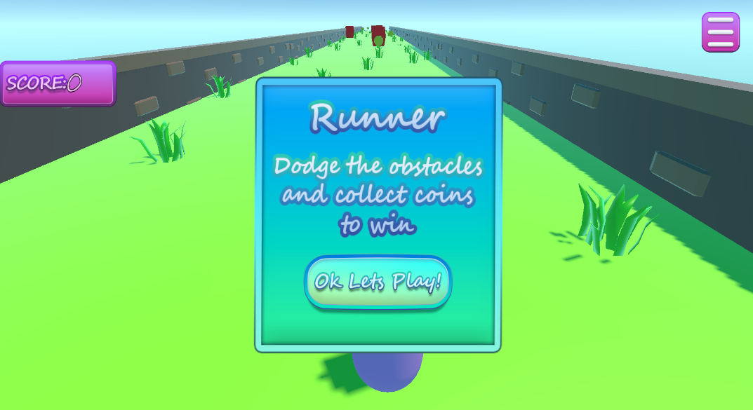

At this stage more development was happening with the UI, every minigame has a popup at the beginning to state what the game rules are and then the player can start the game once they have read the instructions. There was also various testing to ensure the game didn’t start until the player had actively clicked Play. There was some issues with Time.timescale that was later fixed and then reused in the other minigame scenes.

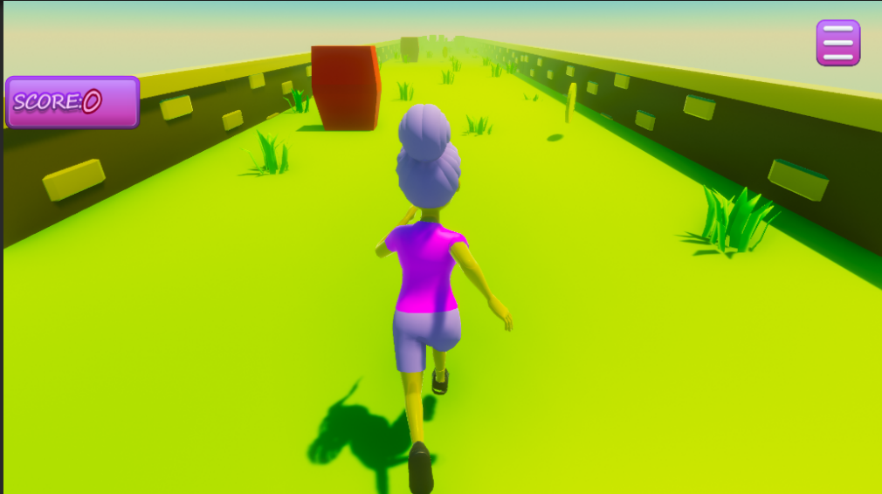

This was the stage of development where the game was starting to look more polished, an imported character was added to the scene with a running animation to give more life and interest to the minigame. There was also some work on the lighting done at this stage using Post Processing which is later mentioned in this report.

**Maze**

Plan and Design:

For this minigame it’s a simple maze game where the player spawns at the start of a Maze and they must find the exit. Throughout the game there are coins for the player to collect that is added to their score count displayed to the screen.

The theme of the game is no set idea, more just a general outside environment with brick walls and pillars for all the corner parts of the maze.

The Menu system is the same as everything else throughout where the player, there is a pause menu with back feature to go back to the arcade room as well as quit function, time is stopped during the pause time.

The coins are laid out evenly throughout the level and the player must collect them, however many coins they collect will be displayed at the end of the level when they find the portal exit.

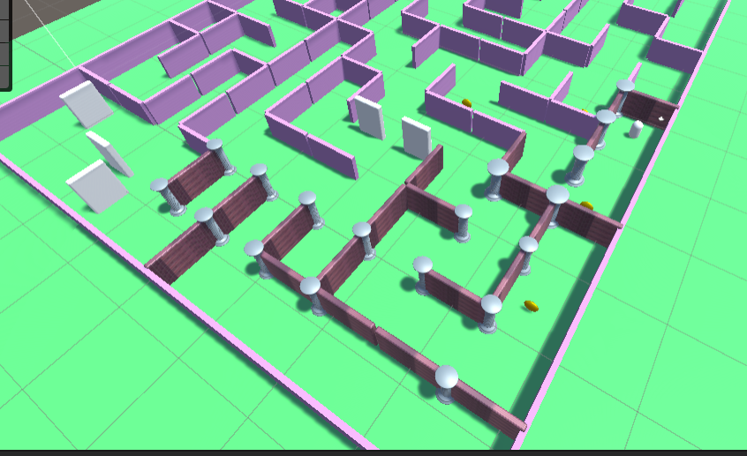

This is the very start of development to the Maze minigame, the first main task was getting an actual maze layout and creating a prototype for the pathing and the player movement. The initial plan was meant to make the player a third person character, but this was later changed to first person as it added a level of difficulty to the game. Having the game first also adds to the immersion of the level as its closer up and the player can’t see over the walls which would make the game easier.

The player themselves is simply the Main camera with a box collider on it to allow for collision and physics in the game, it also allows for the player to collect coins throughout the level.

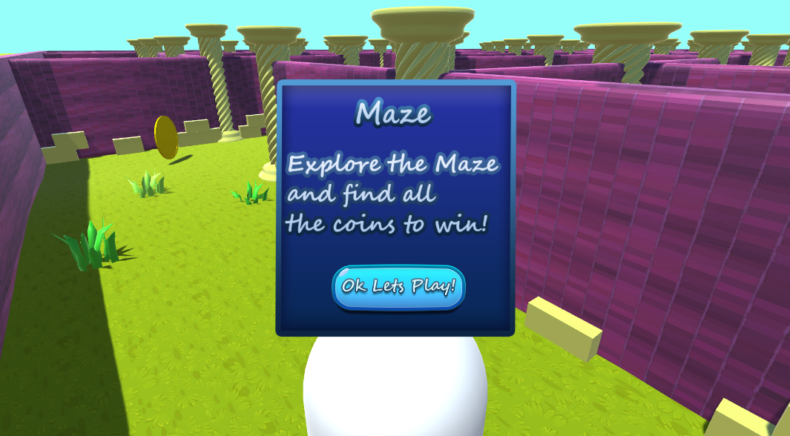

At this state the first-person character was implemented using the capsule as a tester for the collision, The level was also fixed as there was some issues with the wall and pillar prefabs. This was mainly the scaling being inconsistent with the player and the general game balance. The UI was then experimented with to give the player some instructions at the beginning of the game. The ground was also given some texture and some grass models to make it look more polished.

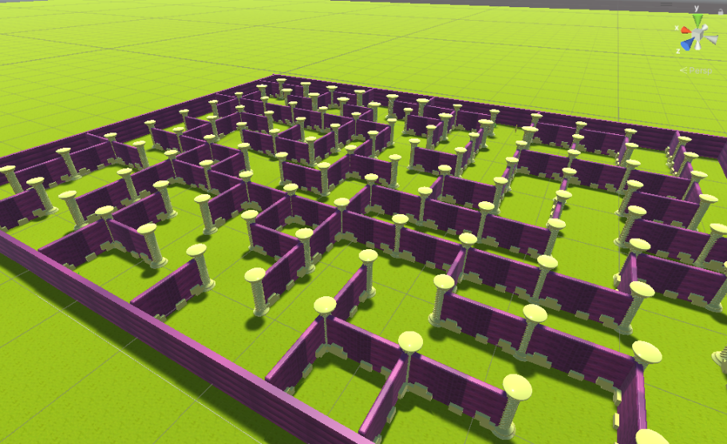

During this stage the collectibles were then distributed around the scene as well as updating the score UI to match the number of coins around the maze.

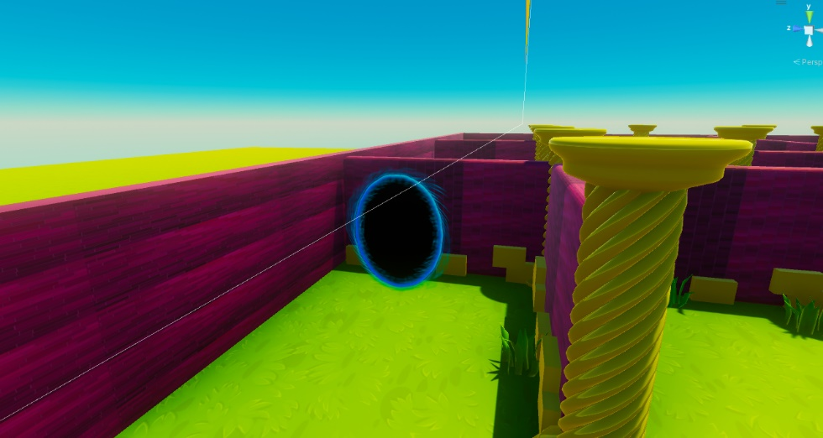

Work was then done to the ending to the maze, the portal exit is found at the end where the player will be shown their score and be able to restart the game or return to the lobby. A collider checks if the player has touched the portal and will display the Win Panel to the player.

**AUDIO**

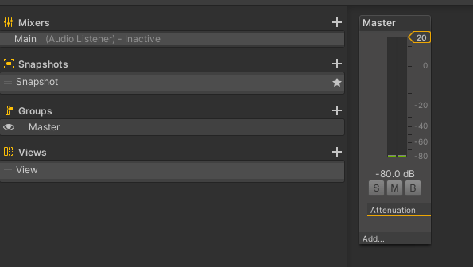

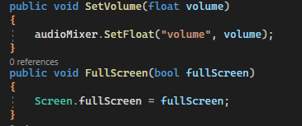

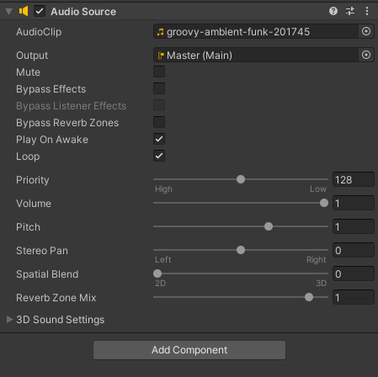

**UI**

**WHAT IS UI?**

**Diegetic:**

This kind of UI is where the interface exists within the story space and world, this can include things like speed dials for vehicles. In the context of this project there is no main UI element that uses Diegetic UI.

**Non diegetic:**

Majority of this project uses this style of UI, as it means that the UI isn’t a part of the story or game space. It’s mainly used to display information or Menus such as stat bars or lives and buttons.

**Spatial:**

Spatial UI is used for aspects of interface that are in the world but are not part of the story. Within this project some spatial UI will be used in the Arcade Room to highlight the minigame machines, it may also be used to highlight interactable objects within the scene.

**Meta:**

This style of UI is where it’s part of the story but not in the game world, this can be used in situations such as when the player takes damage the screen can glow red or other visual effects to make circumstance changes for clearer to the player. This style of UI will be used in the Cat Escape minigame when the Cat player takes damage it will flash red for a second to indicate the health change.

**UI in games:**

User interface in games can be used for various reasons, it can be used to guide the player within the game, allow them to access different features or even be a part of the gameplay itself.  
**Intended UI usage in project:**

The main use of UI within the game will be Non diegetic as it is mainly used to interact with the interface and navigate the game. It will also be used to display scores and allow players to play the different minigames via various popups and animations.

**PRINCIPALS**

**Predict and Pre-empt:**

This principal is deciding what factors are key for the player and what they need. In this instance the players score and pause options are the necessary factors for all the minigames as the players need a way to keep track of their scores as well as have a way to pause the game and be able to exit if needed.

**Complexity:**

This principal is avoiding overcomplicating steps and screens at all possible times, this is to not confuse the user and organise information in a way that is readable and easy to understand. Fortunately for this project there is not a lot of steps for the UI as its mainly there as a utility more so than a source of information. The game primarily uses UI to transition between game scenes and display the players score to them.

It is also used within the settings screen which is all available to the player on the Pause panels used within the game scenes. Rather than using another step to reach a different panel its being displayed all in one screen to avoid complexity.

**Signposting:**

Within the game there are various points that are highlighted to the player that is a point of interest for them. The UI for the project is aimed to be easy to read and understand so that the game is easily played for anyone.

**Accessibility:**

Ensuring the UI is suited for all demographics is a major key element in the UI design, using the correct colours and key binds for different controls can impact a players experience based on their personal background. Making options and instructions clear is a very important part of the overall UX design. For this project all options are titled with names and words rather than relying on colours or textures to show the user what the options are.

**Process**

The initial idea for the UI was to have it static so that it would be easier to lay out all the UI placement and Unity Panel settings.

The UI production started when I decided to create all my own assets in photoshop.

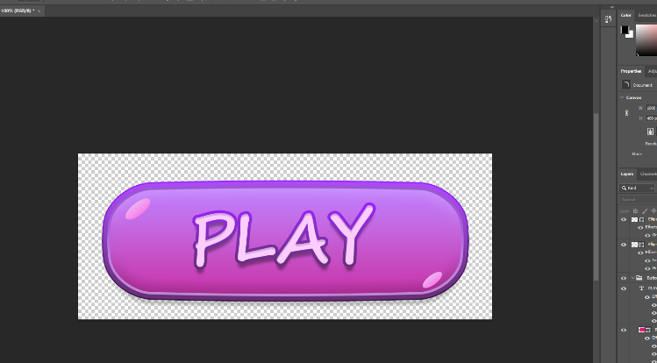

After some experimenting in Photoshop, I decided the style I wanted the UI to be and made various different Panels and Buttons to use in the game. The general UI style I decided to go for was bubbly and bright, so it stands out to the player. I then proceeded to learn more about the different features and tools within Photoshop I could use to make the UI even better.

After creating the Assets and linking them to all the relevant parts, the Canvas was divided into various panels. The main common panels used were the player HUD in each scene as well as the Starting panels and the death panels. Each scene also has a pause panel, they are all accordingly layered in the hierarchy to ensure the correct UI is displayed on top of others.

Once all the key parts of the main UI were completed, some work then began on creating a scene fade transition to allow for a more seamless look for the game instead of them being very static. This was done using Unity’s animation system, by simple changing the alpha value of a black background and having it play the start of each scene.

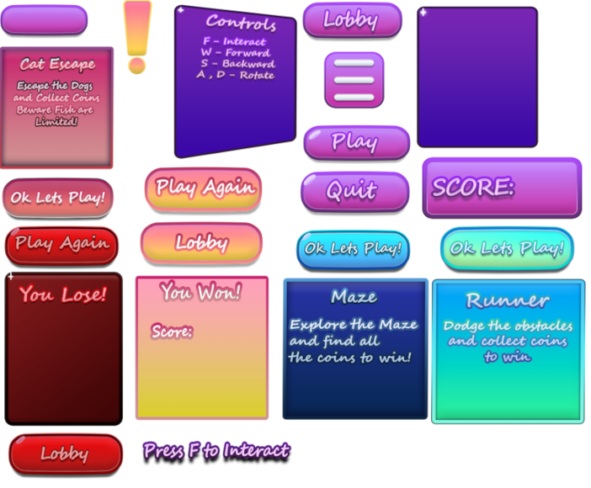

All the UI displayed in the above image is all the assets I created for specific use within the game, its used throughout all the scenes and minigames to guide players through and indicate aspects.

**Lighting**

For the lighting in this project, Post Processing Stack was used to give the games lighting much more depth. The main components used from Post Processing Stack was the Ambient Occlusion which provided much more depth to all the objects in the scene.

The Bloom setting made all the colours in the scene much bouncier and brighter and less static and stiff within the level, it makes the scene look a lot more controlled and natural and less harsh on the visuals.

The Colour Grading allowed the scene to have a warmer temperature and helped with setting the scene and environment to match the skybox.

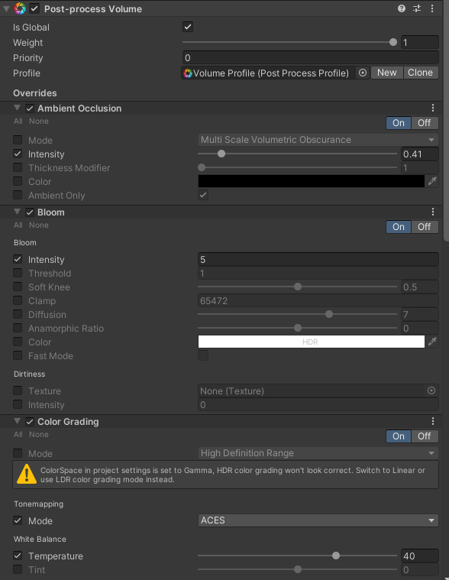

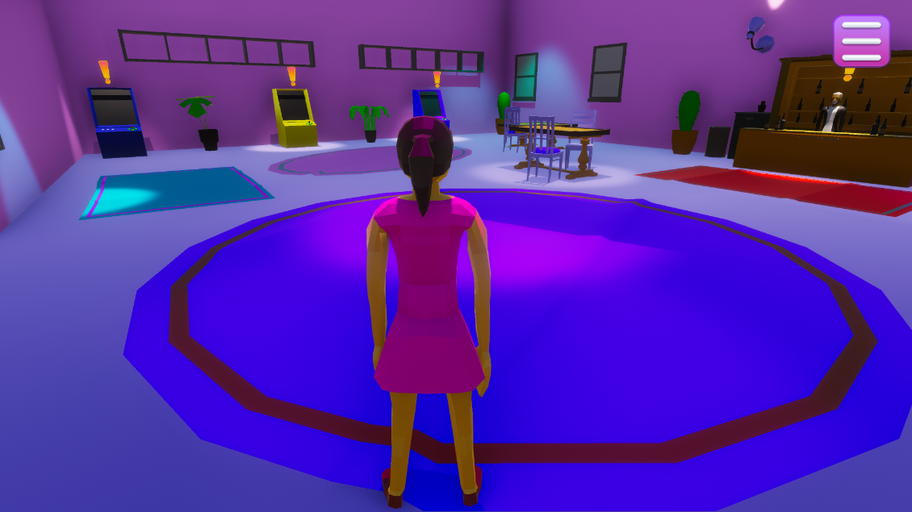

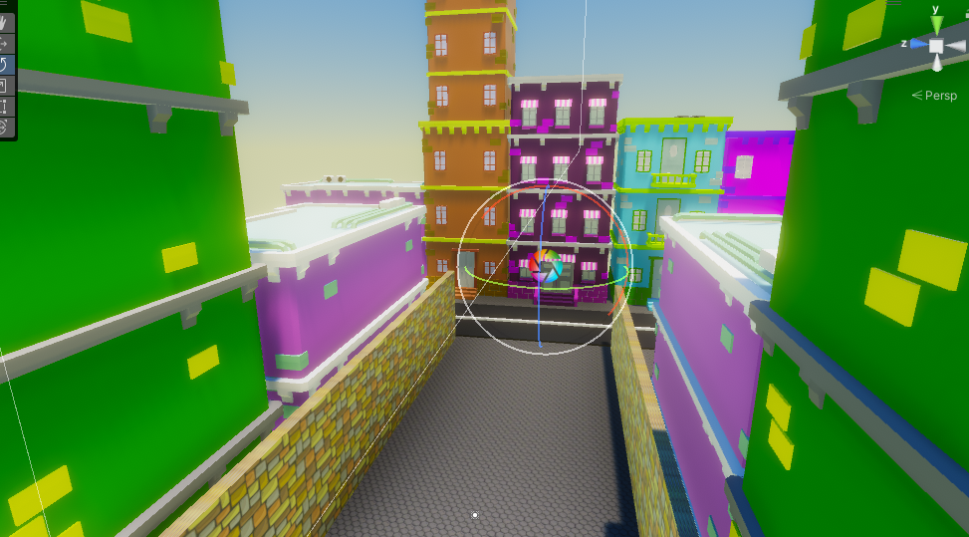

**Further Research**

**Future Development**

Other minigames:

The main selling point of this project is that the gameplay is all minigame based, as such having more minigames available to the player would expand on the game even further allowing further gameplay opportunities as well as possible UI features and add-ons.

More features:

Similar to the more minigames opportunity, possible further development could be added to the game experience as a whole, this can include more visually appealing UI with different animations and different styles for each game.

Some other possible features can be in the main lobby area such as more interactable features for objects as well as some more NPCs for the player to interact with.

**Hurdles**

Code Problems:

One of the first initial code problems I had was the Timescale in Unity was not being set properly and the game would freeze whenever the scene changed, after some debugging the problem turned out to be that the timescale was being set to 0 in a separate script.

One problem within the Cat Escape game was that the dogs would keep moving even though the game was stopped. This was fixed by writing an if statement to check whether the timescale was either 1 or 0 and if it was 0 then the dogs would stop moving towards the player.

Another issue within the Cat Escape game was that when instantiating another Dog it couldn’t find the players target position, this was a simple code error, and the following code was implemented as a fix. 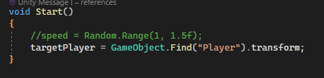

**Time Constraints**

Due to time constraints based on many real-life factors, some features were cut or made more simpler in order to reach a more finished product.

**Conclusion**

The project as a whole has reached a more polished ending, with all the minigames demonstrating their potential as well as the visuals as a whole demonstrating what can be done in the project. It provides a good idea into the main features of the game as well as demonstrating all the mechanics within them. Being able to develop the project from start to finish was a learning experience from learning new software to working with animation within Unity.

**REFERENCES:**

**Textures and Images:**

Menu Brick

<https://www.freepik.com/free-vector/colorful-brick-wall-texture_957410.htm#query=cartoon%20brick%20texture&position=0&from_view=keyword&track=ais&uuid=758e403a-3886-4f9e-a55c-1ad2c9029686>

Menu Stone Ground:

<https://www.freepik.com/free-vector/cartoon-style-stone-texture_1076785.htm#query=cartoon%20concrete%20texture&position=3&from_view=search&track=ais&uuid=b786bc96-863a-4357-992b-b75faa657160>

Maze Wall:

<https://www.freepik.com/free-vector/bricks-wall-background_894094.htm#query=cartoon%20wall%20texture&position=36&from_view=search&track=ais&uuid=649be548-2088-4653-bd4d-5d9da2b18d9d>

Maze Grass:

[https://www.freepik.com/free-vector/seamless-textured-grass-natural-grass-pattern_11930799.htm#query=cartoon%20grass%20texture&position=0&from_view=keyword&track=ais&uuid=12a73418-a761-4592-bbcc-7d4b4ef3f2f8#position=0&query=cartoon%20grass%20texture](https://www.freepik.com/free-vector/seamless-textured-grass-natural-grass-pattern_11930799.htm#query=cartoon%20grass%20texture&position=0&from_view=keyword&track=ais&uuid=12a73418-a761-4592-bbcc-7d4b4ef3f2f8)

Portal Image:

<https://www.pinterest.co.uk/pin/722053752788779664/>

**Models:**

<https://quaternius.com/packs/animatedwomen.html>

<https://quaternius.com/packs/ultimatefurniture.html>

<https://quaternius.com/packs/animatedmen.html>

https://quaternius.com/packs/ultimatefood.html

<https://www.turbosquid.com/3d-models/hyper-casual-characters-male-female-3d-model-2197099>

**Animation:**

<https://www.mixamo.com/#/?page=1&query=running>

**Audio:**

Arcade Room Music:

<https://pixabay.com/music/smooth-jazz-soothing-moments-178951/>

Runner Music:

<https://pixabay.com/music/funk-groovy-ambient-funk-201745/>

Maze Music:

<https://pixabay.com/music/beats-first-days-of-summer-lofi-vibes-205059/>

Coin Collect:

<https://pixabay.com/sound-effects/collect-points-190037/>

Cat Escape Music:

<https://pixabay.com/music/video-games-8-bit-arcade-mode-158814/>

Health Pick up Cat Escape:

<https://pixabay.com/sound-effects/one-beep-99630/>

Menu:

<https://pixabay.com/sound-effects/city-traffic-outdoor-6414/>

**Research:**

<https://dribbble.com/resources/ui-design-principles>